ASSOCIATION OF FUNDRAISING
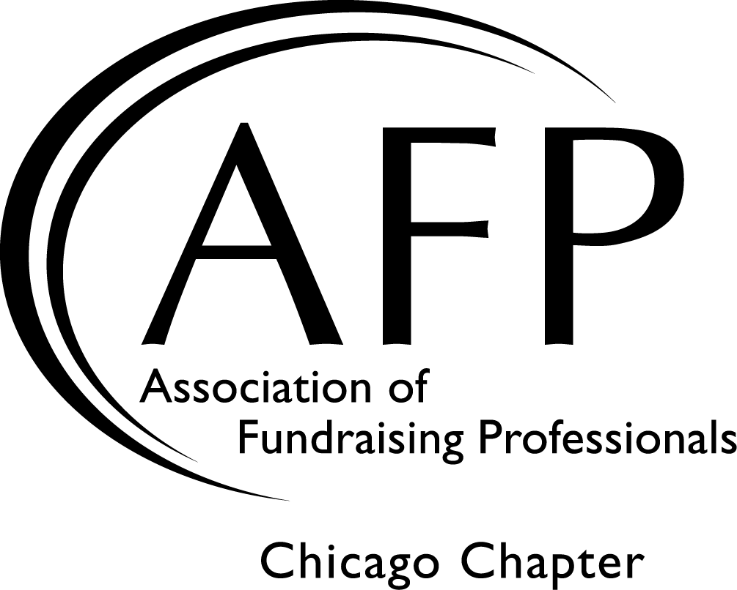
PROFESSIONALS CHICAGO CHAPTER

PEER MENTORING PROGRAM

Protégé Application

CFRE: Yes No
Name: Current AFP Chicago Member: Yes No
Title: Email:
Organization:
Organization Address:
Home Address (optional):
Telephone(s) Day: Eve:
I have access to a car and am willing to travel to meet my mentor: Yes No
My travel time by car should be no more than: No preference 30 minutes 60 minutes
I am willing to travel: No preference or (check all that apply) North South East West

A COPY OF YOUR CURRENT RESUME IS REQUIRED WITH THIS APPLICATION

Years in Development:
SPECIAL MENTORING INTERESTS: Check the reasons you are seeking a mentor:
I am interested in diversifying my development skills
I am interested in increasing racial/cultural diversity among my board, volunteer and donor base.
I would like assistance charting my career path.
I am new to the area and need to build a network of people for assistance for specific projects.
Other
I would like to be elected to participate for the following reasons (use as much space as you wish):

Please indicate three specific measurable goals you would like to accomplish with the assistance of a mentor (use as much space as you wish)
Please do not include my match information in the “Members On The Move” section of the AFP Chicago newsletter.
If selected, I will attend the mandatory kick-off event. (Details available on our website.)
I have read the program details and am committed to participating for one full year:

Signature: Date:

Please EMAIL this application and a copy of your resume to peer-mentoring@afpchicago.org
or mail it to AFP Chicago Chapter Office; 1717 North Naper Blvd, Suite 102, Naperville, IL 60563

A very special thank you to our sponsor:

